Environmental Awareness
A monthly publication of UP BETA SIGMA FRATERNITY, INTERNATIONAL, INC.

Shall We Start Building An Ark?
August 2010
In this concluding article, Brod Popoy Castaneda relates environmental degradation in our forests as having an impact also on our coastal fishery resources, mangroves, sea grass beds and coral reef ecosystems. Brod Popoy says prolonged siltation has been damaging our reefs and corals.

The author concludes that while the Philippines has invested in many environ-mental protection programs, not much attention has been given to the devastation of our aquatic resources due deforestation. There has been international funding intended to save certain species of bat, bird, reptile or corals. Science seminars are held and papers read all extolling to save this species or that species. Yet these have nothing to do with preserving endemism or species diversity.

About the author
With this latest article, Brod Popoy Castaneda is decidedly the most prolific contributor to our Environmental Awareness publication. He must be one of the most well-rounded and talented Filipino environ-mentalists as could be seen from his varied contributions to this website.
(Last of 4 Series)
by Brod Popoy Castaneda, UPLB ‘55

One of the worst consequences of rainforest destruction is soil erosion. Devoid of the protection of the multilayered forest canopy, rainfall will erode the topsoil of cleared forested areas and the cascading water will sweep down slope to the open cultivated areas where it picks up more topsoil laden with agricultural chemicals, the heavily sedimented runoff is then carried by the tributaries and major river systems out to the sea.

During the monsoon rains, even without the accompanying disastrous floods, the plumes of brown heavily sedimented water flowing out of every river mouth out to the sea is a mute but clear testimony of the disastrous impact of silt on the coastal fisheries resources, the mangrove, sea grass beds and coral reef ecosystems.

Although no national statistical figures are available, scientific records show that the coral reefs of the Philippines are considered the richest and the most diversified in the world. Yet these reefs have been and still are being devastated by sedimentation resulting from deforestation.

Heavily sedimented water carried seaward is a silent killer like a plague that has caused the complete destruction and eradication of wide and extensive near shore coral reefs. Like pestilence, it wipes out the reef unnoticed except by a few. Generally blamed for the destruction of coral reefs are overfishing, blast or dynamite fishing and the use of cyanide for the capture of fish for aquarium and food. It is more convenient to blame the fishermen themselves for the destruction of coral reefs, because it seems to be farfetched that an activity like logging in the far remote highland or mountain forests can affect the coral reefs, the mangrove forest and the sea grass beds.

Mangrove forests, sea grass beds and coral reefs are fishery resources. Mangroves and sea grass beds are nurseries of marine animals where their larva or fingerlings are nourished and sheltered. Recent researches have even discovered tuna fingerlings sheltering in mangrove forests. Coral reefs are habitats for a multitude of marine species and are responsible for the richness of fisheries in the surrounding marine environment. Among the three ecosystems, coral reefs are the most delicate and vulnerable to the destructive effect of sedimentation. Coral reefs are colonies of individual marine animals called polyps encased in a limestone skeleton. Living within the tissue of each polyp are single-celled algae called zooxanthelae. They exist in a symbiotic relationship with their host polyp. Being plants, Zooxanthelae manufacture by photosynthesis and supply the polyp with energy such as sugars glycerol and amino acids. They also enrich the ambient marine waters with oxygen and consume carbon dioxide, phosphorus and nitrogen. This is what the coral polyp contributes in the symbiotic relationship besides providing shelter.

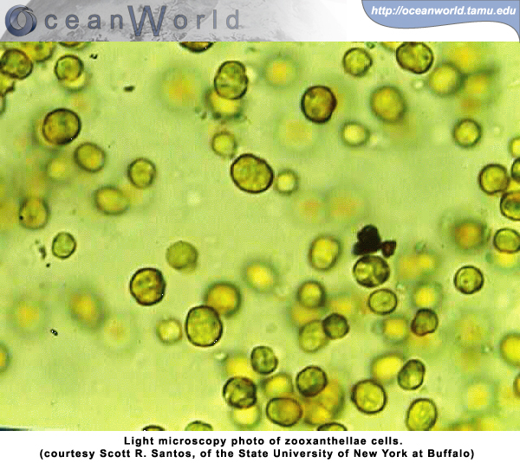

Thus, the life of corals are based on a close symbiotic relation between an animals and plants, silt laden water is turbid which hinders the photosynthetic activity or the food producing activity of the associated zooxanthelae which weakens the individual coral polyp and prolonged water turbidity means the death of the individual polyp.

Many of the other plants and animals that live in and around the coral reef also have symbiotic relationships. Fish with troublesome parasites allow other fish to pick off the parasites. The parasitic fish get rid of the nasty bugs and the helper fish get a free meal. Certain fish are immune to the sting of the jellyfish. That means the sting does not hurt them. They take shelter among the jellyfish's tentacles, thereby baiting a trap for other fish. In return, the fish get to share the meal with the jellyfish. Some crabs will pick up sponges and seaweed and place them on their back. The crab is camouflaged from predators and the sponges and seaweed enjoy better food selection. Symbiosis helps to create the reef community.

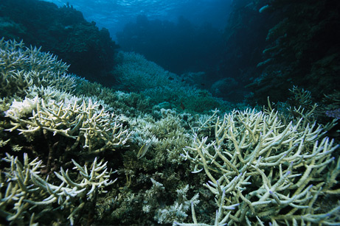
Weakened corals run the risk of erosion

Prolonged siltation also deposits silt and sediment on the coral beds smothering the reef and since in most cases the silt and sediment also came from agricultural areas the silted water is also liberally laced with agricultural chemicals another polluting factor that kills the reefs.

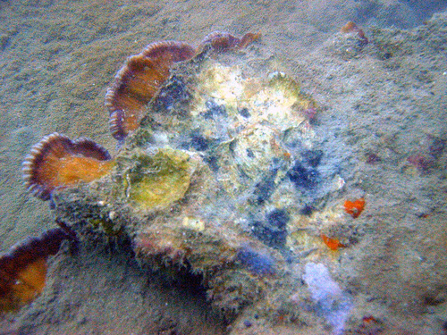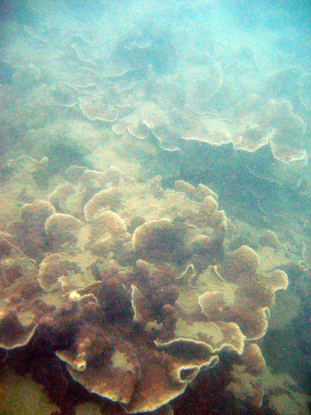
Coral bleaching due to siltation Siltation and damaged corals

Siltation causes the water to become choked with mud and all life that depends on that clean water eventually suffocates. Last but not the least, the freshwater of the floods alters the salinity of the coral reefs marine environment and coral reefs have a very narrow tolerance to changes in salinity and clear drinking water is a pollutant for the corals.

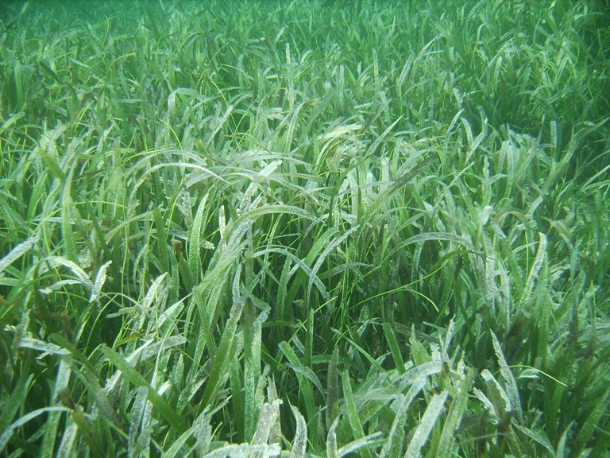
Sea grass beds are vulnerable to siltation

Next to coral reefs, sea grass beds are very vulnerable to the adverse effects of siltation and sedimentation due to rainforest destruction. Sea grasses are not seaweeds but are really grasses, seed bearing plants adapted to the marine environment, they bear flowers which and produce seeds, and like other plants they manufacture food by photosynthesis and sunlight is vital for this process. Heavily sedimented water are turbid hindering the penetration of sunlight which is a detriment to the food manufacturing activity of the plants. Also, chronic sedimentation has buried under thick sediments entire areas of sea grass beds. To put the final nail on the coffin, the destruction of rainforests which cause floods during the rainy months and no fresh water during the dry season alters the salinity regime of the coastal areas causing stress to the plants. Salinity regime is the seasonal variation of salinity in the estuaries and near shore coastal marine waters which is more or less constant with an intact rainforest catchment and which the plants and animals have adapted to. The destruction of rainforests in the catchments dramatically alters the seasonal but constant variation of salinity causing distress to the affected ecosystems.

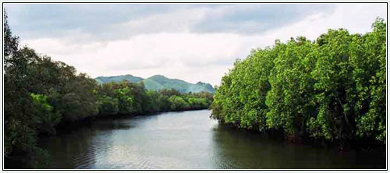
Bohol mangrove forest

Mangroves are plants that have adapted to the marine saline environment. Some species have a high tolerance for salt water and are adapted by nature to remove the salt in their system. They have aerial roots that allow them to breathe while immersed in salt water, and are able to tolerate the periodic immersion dictated by the tides of the sea. Different mangrove species have different levels of tolerance to salt water. Those with high saline tolerance occur seawards while those with less further inland. Mangrove species unlike sea grasses are mostly trees and are relatively tolerant to sedimentation coming from the uplands; however, they are dependent on the integrity of the salinity regime.

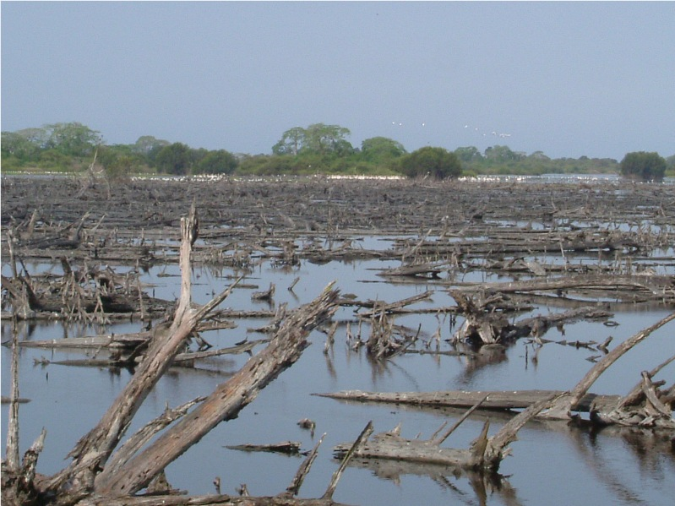
Damaged mangrove forest due to siltation

The destruction of the rainforest in the upland catchment drastically and dramatically changes the salinity regime of the estuaries of the rivers downstream where the mangrove and sea grass ecosystems are. This causes a gradual change in the species composition of the ecosystem. A mangrove area where the trees have been cleared for timber can be replanted and rejuvenated in a matter of years, but an area where the salinity has changed because of the destruction of the forests in the upland catchments will give you a stunted mangrove cover. A mangrove forest that is stunted cannot offer the same productivity of an original mangrove forest. This is illustrated in areas in the coast where the salt tolerant Rhizophora (mangroves with stilt roots) have been replaced by Nipa palm a mangrove species that favors a less saline environment.

A stunted mangrove forest composed of nipa palms cannot duplicate the original mangrove forest in giving shelter and food that is produced by the leaf litter (Ditritus) which is the food that fingerlings and the fish larva thrive on.

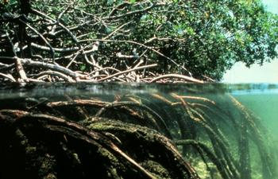
Panay Island mangrove forest

In the Philippines, Fishery productivity is dependent on very healthy and thriving mangrove, sea grass, and coral reef ecosystem. Majority of the population depend on fishery not only for livelihood but for food source as well. Even the mountain dwellers are fish eaters, with a rapidly growing population that exerts pressure on the fishery resource. More areas such as the central Visayan seas are becoming overfished and with the destruction of mangroves, sea grass and coral reef ecosystems, this is like burning our candle at both ends. We Filipinos are very happy with what we have accomplished for our environment. We have natural heritage parks and national parks as show cases. We boast of being the apex of the coral triangle, a centre of marine species diversity, and forests sheltering a number of endemic species. There has been international funding intended to save certain species of bat, bird, reptile or corals. Science seminars are held and papers read all extolling to save this species or that species. But this is not about preserving endemism or species diversity. For us Filipinos it is about survival. With the destruction of our precious rainforests we are destroying our country.

Yes, we can build an Ark, but the question lies on where we can go afterwards.

