Environmental Awareness
A monthly publication of UP BETA SIGMA FRATERNITY, INTERNATIONAL, INC.

May 2010
This is the 29th issue in 29 months since we started this publication in January 2008. We had planned that beginning 2010, we would decreasing the frequency on a quarterly basis. Yet, the articles keep on coming from month to month. We have exceeded our plan to slow down with just 4 articles this year. This is a clear indication that ningas cogon is not part of UPBSFI’s dictionary.
This issue advocates the restoration of rainforests in the Philippines as a long-term solution towards the prevention of floods in lowlands like Metro Manila.
About the Author
Sydney-based Brod Porfirio “Popoy” Castaneda (UPLB ’55), our talented environmentalist, follows up with his article he wrote last month. He immediately went to work right after a recent successful eye operation to offer the readers more information about the floods that continue to besiege Metro Manila. All photos in this article were taken by Popoy.
Popoy is among the mid-50s Brods who has served the frat almost non-stop, in-between his colorful adventures as a political activist, a fugitive during the martial law years, and a marine-life expert and consultant. Even as an alumnus working in UP Diliman, he served as 1st Vice Grand Princep way back in the early 70s.

SHALL WE START BUILDING AN ARK?
Part II: Why Rainforests
By Porfirio “Popoy” Castaneda

The Philippines has always been subjected to floods due to extreme weather conditions, the excessive rains from the Monsoon and the combined effect of recurring typhoons. However in the last 40 years or so, floods begun to occur with regularity and frequency, even with just a light downpour, there would be flooding during the monsoon rains and then a deficit of water in the following dry season. These calamities have been accepted as part of the natural cycle.

But, as the years went by, more areas of the archipelago were subjected to floods with accompanying landslides, with the damages getting more severe that have been telling on our roads, bridges, and other infrastructures. Private properties and lives were lost. The alternating dry season results in shortage of water curtailing the ability of dams providing hydroelectric power to supply electricity, to include water for irrigation and domestic use.

The nation’s capital, Manila and the surrounding areas including its satellite cities have always borne the brunt of periodic flooding. Last year in September, Metro Manila by far suffered the most devastating flood. Again the blatant causes are the combined effects of the excessive monsoonal rains and the recurring typhoons, which over flooded Laguna de Bay and all the water impounding dams in Luzon. Other areas were also flooded -- Central Luzon, parts of the Bicol region and some islands in the Northern Visayas. Yet barely four months has elapsed and those dams, especially the ones supplying hydroelectric power and water for irrigation, are already below critical levels. The agriculture-rich Cagayan Valley is presently suffering from the effects of a localized drought that has damaged crops all over the area. Again this was accepted as a natural occurrence even to El Nino, a dry wind phenomenon that has a regional not a localized effect. El Nino serves as a warning of the effects of global warming and changing weather patterns.

It is true that floods and dry periods have always been part of the natural cycle, but floods and drought did not occur with such frequent regularity that we suffer at present. For centuries, the Philippine Archipelago was blessed with a liberal cover of tropical rainforests. Most of the mountain slopes and the highlands were thickly carpeted with forests leaving only the rich valleys and narrow coastal plains for agricultural and human settlements. At present only 20 percent or less has been left and only 3 percent of the original old growth remains standing. In an archipelagic nation like the Philippines, Tropical rainforests are a vital life support system, not a renewable resource to be exploited and used even at sustainable levels.

At first glance a tropical rainforest appears to be a community of plants with the large and towering hardwood trees forming the main structure and framework. But the multi-storey or layer of trees, network of vines, the epiphytes, the saplings and smaller plants that occupy the lower

canopy and the forest floor is occupied by various animals or living organisms from the smallest insects to the biggest animals occupying the top of the food chain, such as pythons, monkeys and the forest eagles, the largest of which is the Philippine Eagle, our national symbol.

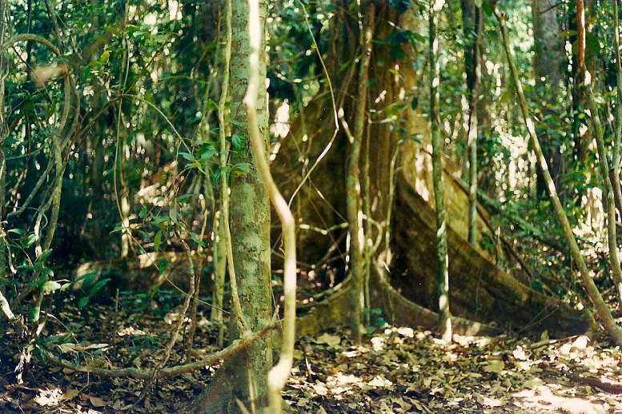
Buttresses of tall trees and small trees at the forest floor

All of those animals do not just live in or use the rainforest as a shelter or abode, the animals and the plants have been molded together by nature, so that every living thing in the rainforest ecosystem are connected to each other. The tropical rainforest abounds in interconnections and relationships or partnership. The tall trees and bigger shrubs is a framework on which other plant use as a support. The branch of a tall dipterocarp provides support for an orchid or a fern to grow on; the roots of these plants in turn provide shelter for insects, such as ants.

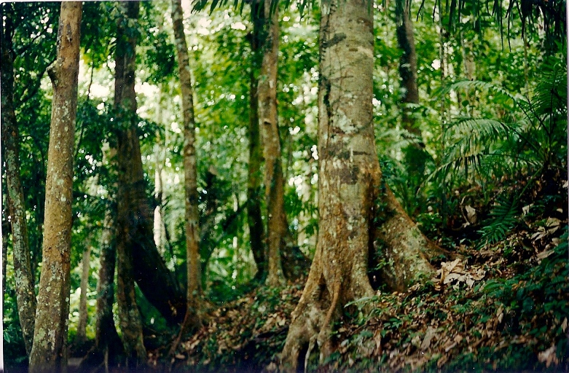
The forest floor with leaf litter

As well as partnership between plants, the rainforest is replete with plant and animal partnership. For instance, a species of bats relish the nectar of durian flowers which open only at night. The durian flowers in turn depend on this particular bat to fertilize its flowers to develop into fruits. The durian fruits when ripe fall down and emit a strong odor to attract fruit eating animal like a Civet Cat to eat it. The Civet Cat acts as a dispersal agent for the durian when the animal voids his feces somewhere in the forest. The seed needs to pass thru the digestive system of the said animal thus resulting in germination of the plant. The Civet Cat not only does this function for durian trees but any other fruit it eats. These examples illustrate the fact that a tropical rainforest ecosystem is a single living dynamic entity and anything big or small taken away from the ecosystem diminishes its function.

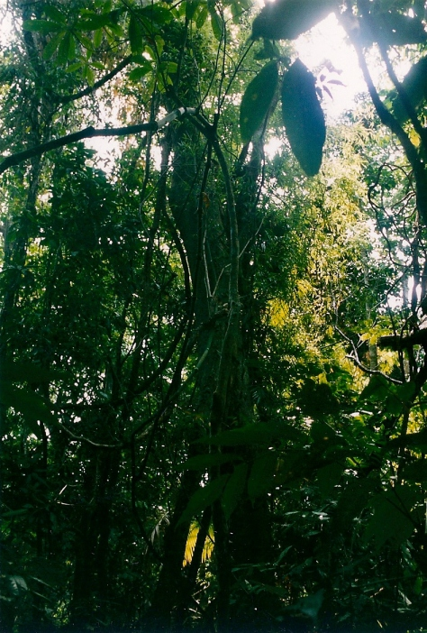
Vines or lianas drape the tall trees.

But it is sad to say that humanity has regarded rainforests as natural resource to be exploited. Even the most primitive of societies who live in these forests utilize their environment as a source of food, shelter, transportation and weapons. They use palm leaves for thatching for their shelter, make bows and arrows from bamboo and wood, and cut down big trees to hollow out a canoe. This is the case with subsistence societies like the Indians of the Amazon. Here in the Philippines, the rainforests have been exploited commercially since the Chinese traders anchored off the shores of Mindoro to trade for hardwood and various forest products. The decades that followed especially with more activities related to trade and commerce intensified, exploitation of Philippine forests multiplied. The developing world required more timber, and the rainforests supplied the best hardwood available. As the pressure of the demand increased, exacerbated by high population growth, exploitation of our forests became indiscriminate. Sadly, what we have left is 3 percent of the original old growth forest and less than 20 percent forested area most of which are technically secondary growth forest.

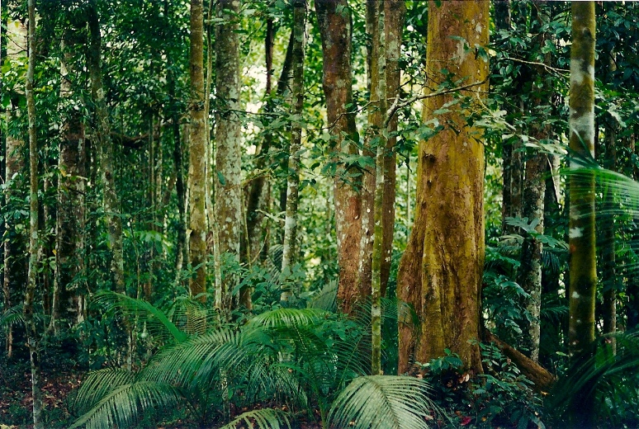
Rainforests contain a huge volume of vegetative bio-mass.

However in a small island ecosystem like the Philippine Archipelago where only 2 islands can be regarded as large, even the islands of Luzon and Mindanao are small compared to the other larger islands in nearby archipelagos. Intact rainforest ecosystems influence the climate and the composition of the atmosphere, by transpiring copious volume of water vapor, moderating the effect of excessive or inadequate rainfall and extremes of temperature. Other forms of plant communities like pine forests in the temperate regions can do this but the rainforests with far larger biomass and existing in the moist equator does this function better than the other forest type. Also the large vegetative biomass of the tropical rainforest absorbs a significant volume of carbon dioxide from the atmosphere and gives off oxygen in return. Again the rainforests can do this function best because of the great volume of plant biomass.

Besides moderating the effect of excessive or lack of rainfall, rainforests are also useful in the conservation of water. Intact rainforests covering water shed or a water catchment enables rainwater to seep in and replenish to full capacity aquifers or underground water deposits. In reverse the rainforest cover protects the area from soil erosion during periods of incessant and heavy rainfall. Thus dams whose catchment or watersheds have intact rainforest cover will continue to be filled and replenished even during the peak of the dry season. When water shed has inadequate forest cover, or in extreme cases devoid of such, heavy and incessant rains initially erode the topsoil. Topsoil is rich in organic matter which functions like a sponge that absorbs water in the case of an intact rainforest ecosystem. Subsequently, the topsoil is washed down the slope without it seeping down underground to refill the aquifers. The silt and topsoil will pollute the river system downstream, leaving a barren water catchment unable to store water during the periods of heavy rains and in turn cause flooding in the lowland.

This is currently what is taking place in our beloved Philippines.

