Environmental Awareness
A publication of UP BETA SIGMA FRATERNITY, INTERNATIONAL, INC.

Celebrating the Earth
May 2012
This particular issue is the third of its kind. But while the focus is on Placer County’s celebration of Earth Day, the author also took photographs on the County surroundings showing the results of environmental programs that were undertaken by the government in cooperation with the private sector and the residents.
Many of these photographs are meadows and wetlands located a block away from his home. What is quite remarkable here are hundreds of sheep sent to graze the meadows, a growing practice in several parts of California.
Now on its 36th Issue, Environmental Awareness has dealt with various aspects of our Mother Earth – from useful and innovative farming and gardening tips, to the advocacy for cleaner ocean, rivers and air; from rainforests and marine life, to environmentally oriented exhibits in localities; from the destabilizing effects of the Arctic and Antarctic meltdown, to the perennial flooding problem in Manila; from toxic conditions brought about by poor garbage management, to problems encountered in our very own Centennial Forest in UP Visayas and how we have been able to cope with them.
The commonality among these contributors is their philosophy that the environment should be preserved and protected so that our children and grandchildren will continue to enjoy the blessings of Mother Earth.

A California County Starts with the Very Young
By Willie “Tatang” Vergara
To the Placer County of California, everyday is considered as Earth Day. For this reason, the air and water are noticeably clean, the parks and residential areas are green, the lakes and rivers abound with fish, the wetlands have a wide variety and increasing wildlife, garbage collection and recycling of waste is impeccably efficient, and people here in general have environmental protection on top-of-mind. Having lived here for the past 16 years, I have witnessed this mentality of the residents evolve into one that has resulted in abundant benefits to the people and the area.
I will not be surprised if Placer County is considered a ‘model’ on the matter of environmental promotion. The reader is requested to consider these information as additions to the ones that were shown in earlier articles, including two previous ones that relate to the surge of salmon in Sacramento.
This is the 5th consecutive year that the county embarked on this project. However, this year’s celebration was the grandest and most well-attended thus far. Consider the following, among several other participants:
At least a dozen local government agencies plan were on hand to share information. The Planning Department, for example, provided information on the Placer Legacy Open Space and Agricultural Conservation Program. Public Works highlighted the Storm water Quality Program and alternative transportation options. The Air Pollution Control District showed its Spare the Air Program and efforts to phase out use of wood-burning appliances that do not comply with U.S. Environmental Protection Agency standards. The Agricultural Commissioner’s Office focused on noxious weed eradication and the county Office of Emergency Services discussed biomass options as a wild-land fire reduction strategy and clean energy source. The Placer County Mosquito Abatement District to took sign-ups for mosquito fish, which are designed to help reduce mosquito populations.
Several vendors (including ‘green’ clubs and associations) were there to offer eco-friendly products and services – solar panels, organic gardening, water-wise watering systems, local plants for xeriscaping, eco-oriented plumbing and electrical systems, and many others. Among the highlights of such products are electric cars and motorcycles.

The Earth Day celebration 2012 abounds not only with various booths but also with the participation of grade school children especially during the entertainment portion of the celebration. To borrow an old phrase, “the pictures (below) are equivalent to a thousand words.”
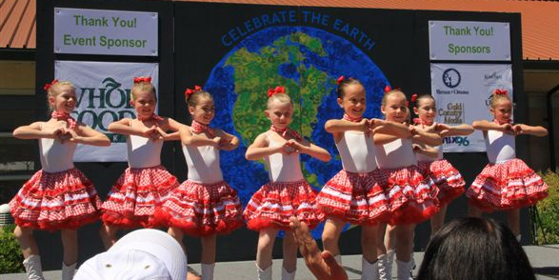
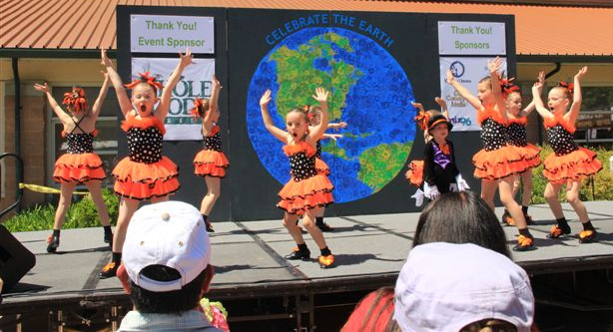
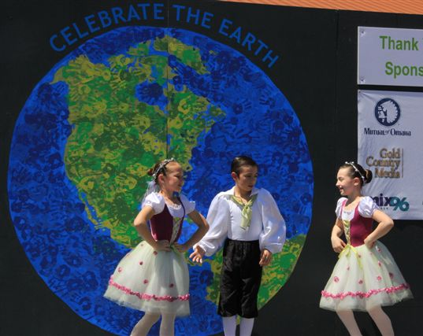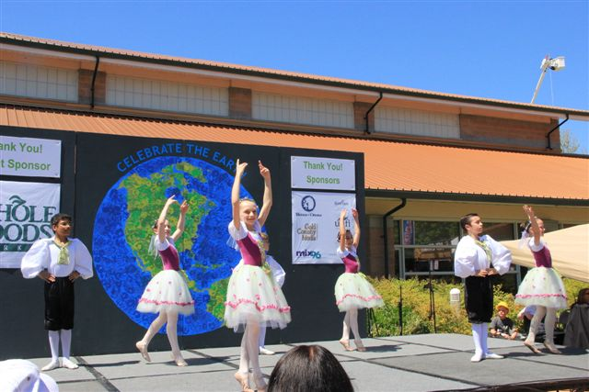

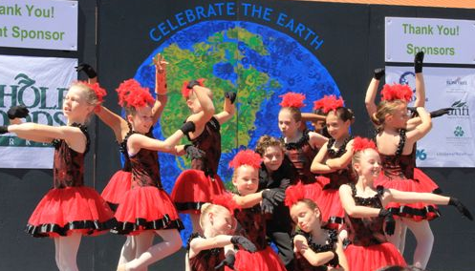
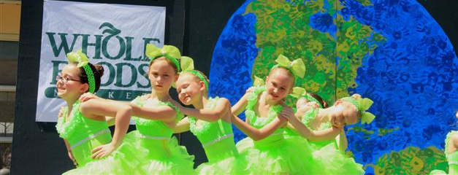


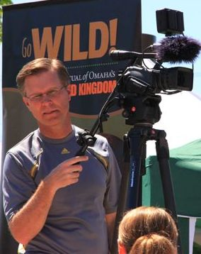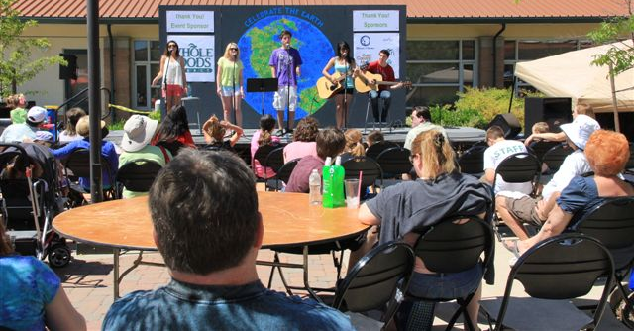
The County has truly made this annual celebration very attractive to children of all ages by increasing the number and variety of playground facilities, fun activities such as computer games, “touch the animals”, face-painting, hit-an-object and win a prize, spin-a-wheel, and a magician cum ventriloquist show.
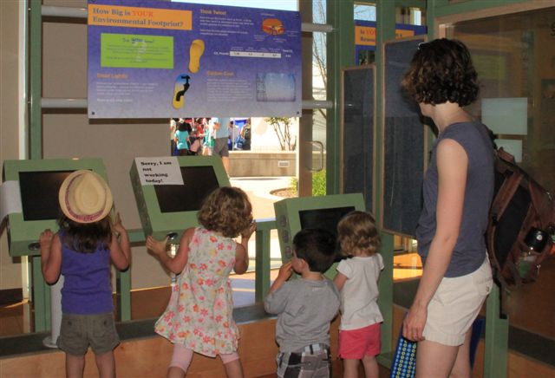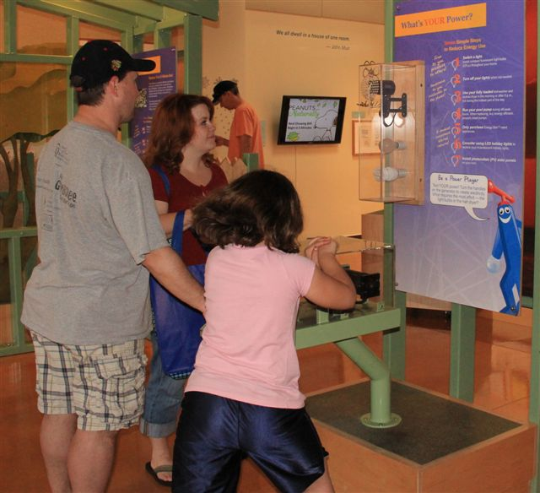
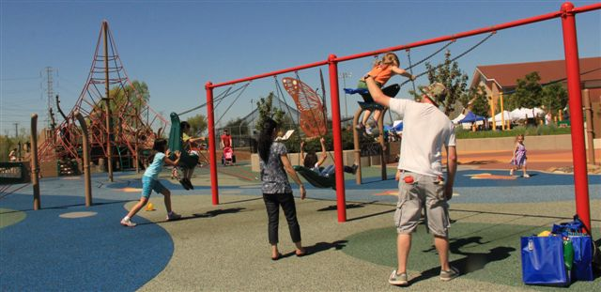
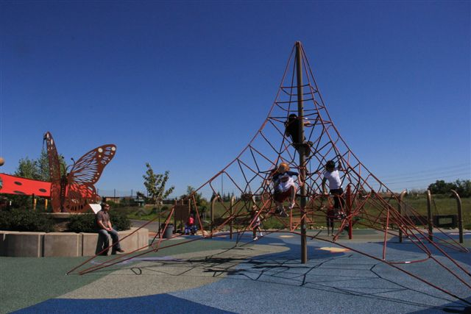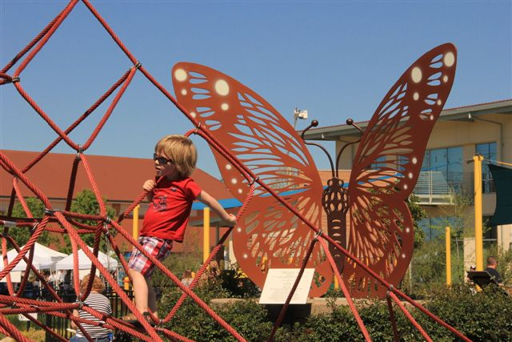

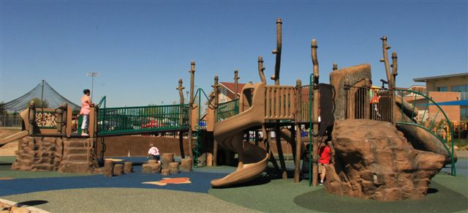

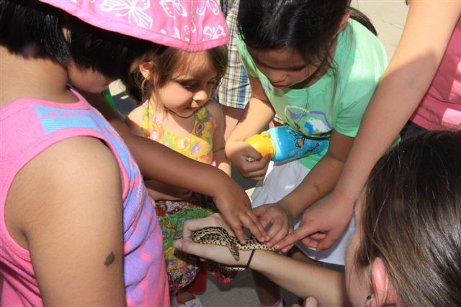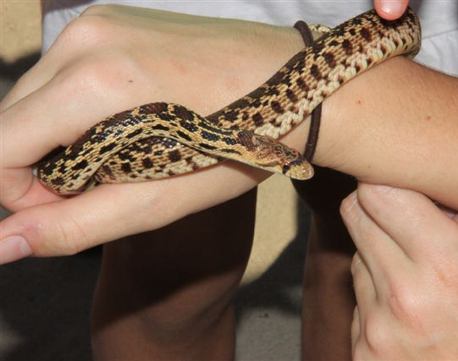

Over the past year, I happen to engage myself in conversations with children as young as pre-school. Every time, it has always been a pleasant surprise to know that they are very much environmentally aware. The depth and breadth of their knowledge is amazing and at times even use terminologies like “storm-drain”, “xeriscaping”, “wetland preservation” as part of their day-to-day lingo.

Among the new attractions during this year’s festival are electric cars and motorcycles right at the entrance of the fairgrounds. Clean fuel is one of the major items being promoted by Placer County.

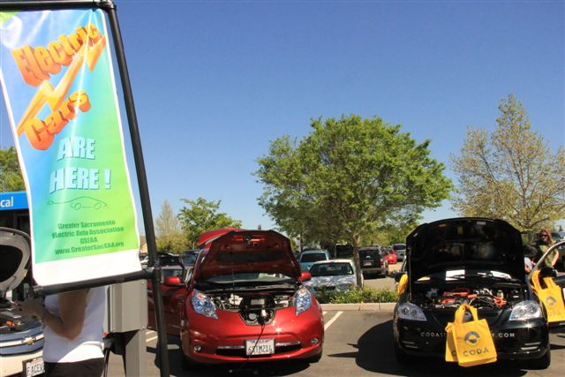

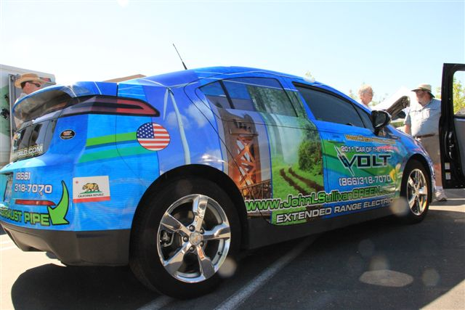

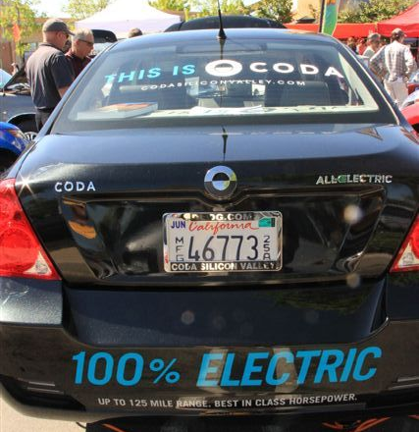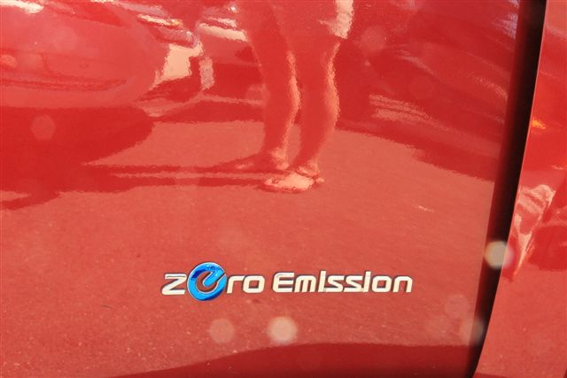
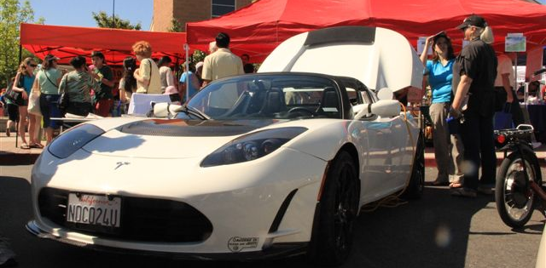



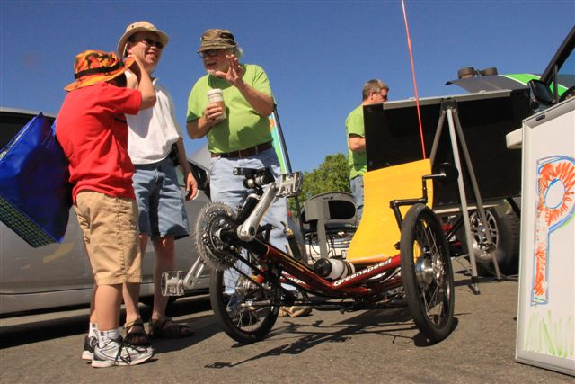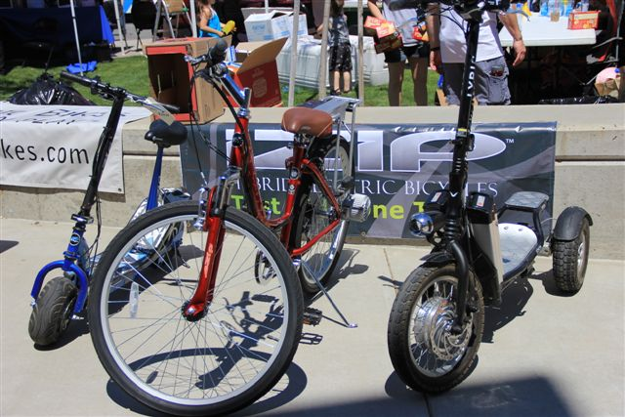

As I visited each of the booths, it was a pleasant surprise for me to see my son inside the fair with his family in tow. The pictures below are Lani Cabral-Vergara (daughter of Brod Mino and Sis Lea of UP Los Banos), my second grandkid Nico, baby Carlo and my son Carl. Come to think of it, my 6 month-baby grandkid is getting his first lessons in environmentalism even before he even starts to walk or talk!

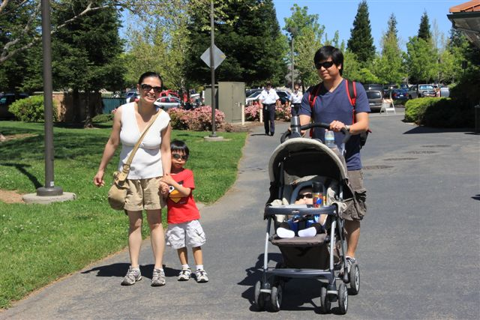

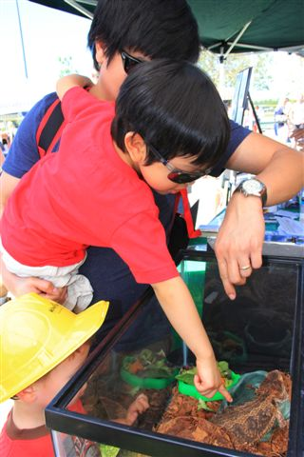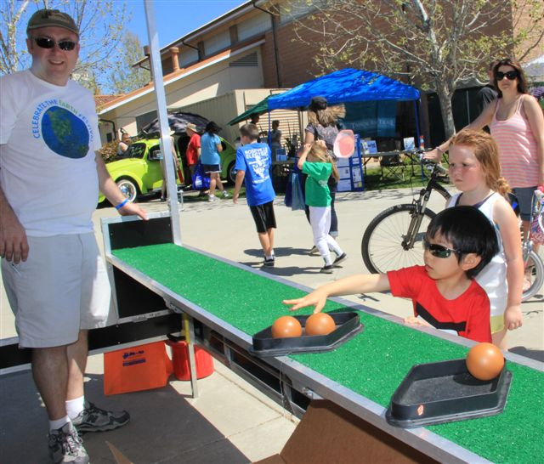

The place was filled with happy faces much akin to a Disneyland atmosphere. It appears that there is magical effect in advocating for the preservation of a clean environment. Those who came to visit the exhibits went not only to be entertained, but also to get involved in friendly conversations as well. In my case, for instance, I was invited to join the photography contest of the Sierra Club. To cap the day, a lady at a radio booth encouraged me to try my luck at a game of cards. “I don’t even win at office raffles,” I replied. Since there was no expense involved on my part, I tried my luck just the same. And look… I now wear the red T-shirt I just won by playing the game!



There are so many things to write, and so many pictures to show about this event. But I will stop here. Besides, for more information about this yearly festival, one can always refer to two other articles at our Environmental Awareness section. Specifically, these are the publications way back in May 2009 (Think Globally, Act Locally) and April 2010 (Earth Day, Special Edition).

I intend to write a sequel of this issue very soon. It will be about the benefits that the County residents are enjoying on account of all the cooperative efforts of the government, private industry, clubs and associations, and the residents towards environmental protection. Meantime, allow me to greet you a resounding …

HAPPY EARTH DAY!

